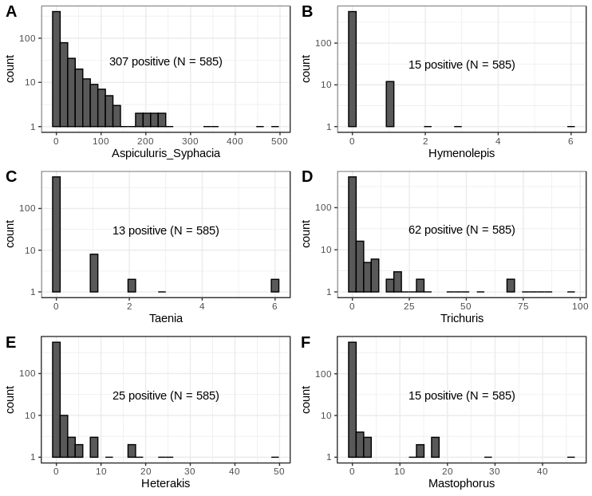
Supplementary Figure S2. Distribution of helminths counts in all mice investigated for worms (N=585)

